**ECSE 682 Assignment 3 Report**

Yicheng Song 260763294

Xiangyun Wang 260771591

2022/11/22

**Introduction**

In this assignment, we developed a pedometer using thunderboard as a Bluetooth GATT server and smart phone as Bluetooth GATT client. The thunderboard will collect and process acceleration data to count steps. The application on smart phone will connect to thunderboard directly and receive the step number. Similar to assignment 2, in the application the user could set goals for step number, calories and distance. As shown in figure 1, the goal and current exercising data are recorded and showed in two columns. To set the goal, the user can press the “SET GOAL” button to access the view shown in figure 2. After typing in the goals, the user can press “SET” button to return, or press “RESET” button to clear the fill-in content. The step counting will automatically start. Once each goal is achieved, a notification will pop out. By pressing the “RESET” button, the user could clear the current exercise data.

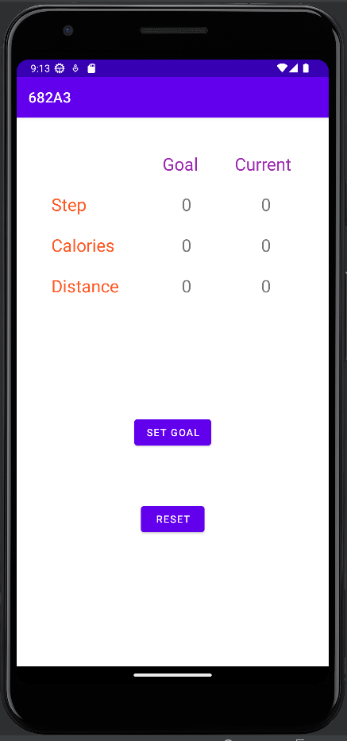 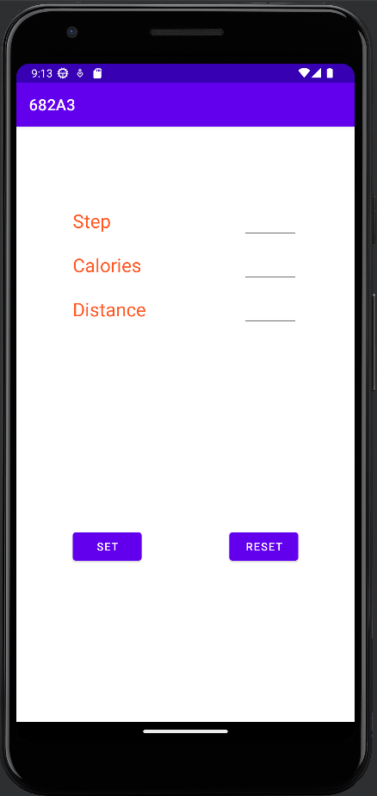

Figure 1. Main View Figure 2. Set goal view

**Implementation**

This project consists of 4 main parts: thunderboard step-counting algorithm, Main activity, Set goal activity and BLE service.

**Thunderboard step-counting algorithm**

Assuming that the maximum walking/running speed for human beings is 4 step per second, we set the working frequency of accelerometer to be 10 milliseconds, and the

**Main activity**

**Set goal activity**

**BLE service**